CHAPTER-1 INTRODUCTION TO ORGANISATION

HCL Career Development Centre (CDC) is the training arm of HCL Learning Ltd. ®It offers a complete spectrum of quality training programs on software, hardware, networking, industrial /project training and various other new-age courses as per the trends & demands of the industry.

HCL CDC Ludhiana is an initiative that enables individuals and organizations to benefit from HCL's expertise in the IT space. The Company has ventured into the field of IT training with an objective to meet the increasing demand of skilled professionals across the country.

The training programs delivered through a network of 50+/CDC centers spread across the country. CDC centers have state-of-the-art infrastructure and expert faculties who groom students for the corporate world by imparting training in specific technologies and have cumulatively trained more than 2[Mn+] students.

HCL CDC is proud to have been associated with governmental bodies in a number of social and skill enhancement projects. Through active collaboration with the industry, we have the capability to deliver enterprise IT training solutions fully customized to the requirements of our clients. Our trainers are multi-certified in IT and other technologies and have many years of rich experience in delivering instructor-led sessions to government and public-sector employees.

Our alliance with leading IT corporations such as Microsoft, Red Hat and SAP provides us with valuable inputs for augmenting our curriculum as well as in adopting global best practices in IT education. Our training solutions are designed to help you stay competitive today as well as in the future.

At CDC they believe that the students should be given a hand on experience and thus all the courses are a blend of theoretical and practical implementations .HCL CDC also offers global certifications in association with leading organizations worldwide.

Course curriculum has been designed in a manner to increase the employability factor of the students. Under the aegis of HCL and strong associations within the industry CDC is able to provide better placement opportunities to the students.

CHAPTER-2 INTRODUCTION TO PROJECT

2.1. OVERVIEW

This project ‘GencoGeeks’ is an ***Online Learning***-based project which is made for a case university which wants to implement online education for its students.

Main stakeholders of this system are the university management, faculty members and students of the university. Present system of the case university is the simple university website with its simple different applications. These systems are only sufficient for dealing with regular students.

The proposed software product ‘GencoGeeks’ will be used to upload/download lectures, upload notifications to the students, conducting online tests for the enrolled students and reviewing the test results by the students. The proposed software system also includes a payment gateway which will enable the students to pay the registration fee online which will completely eliminate the need for any manual work.

Also, the proposed system can be used for the regular students and may also be used to attract other potential students from outside the university. As there are no time constraints involved in the proposed software system, the students can effectively utilize their free time by learning online by watching the videos. Furthermore, there is also a provision for students to check their level of knowledge gained by taking up several online tests.

In addition, the proposed system also includes a discussion forum where the students will be provided with the facility to ask any doubts regarding the available subjects on the website.

So, overall this project combines several aspects of online learning into a single system:

* Watching online videos/lectures to enhance knowledge.
* Taking up tests to check the level of acquired knowledge.
* Ask any doubts in the discussion forum available.

2.2. EXISTING SYSTEM

The existing system provides the students of the university with the opportunity to learn different subjects which are a part of the curriculum but does not provide a way to the students to enhance their knowledge by learning new skills apart from the regular curriculum. The students are taught the regular subjects in each semester followed by exams and vacations of over a month’s period.

In this existing scenario, the students cannot possible join any training center to learn new skills. And even during the vacation period, they have to look for good institutes which impart training and also there is no guarantee of the quality of training provided in these institutes.

Alternatively, even if the students choose to go online to study, there are not much scope for students on their own because as a beginner, they can distinguish good content from bad. Therefore, there is no guarantee of the quality of training acquired. Also, even if the students are able to acquire the skills from online forums, they will not be able to check the quality of the acquired skills. For that, they will have to search for another good forum which can provide them tests to check their level of knowledge. Furthermore, if the students have some doubts regarding some of the topics, they will have to look out for yet another forum to ask questions in order to clear their doubts. All this will make the process of learning time-consuming and cumbersome.

So, to avoid all this and to make the students of the university competent professionals, this system has been proposed. This system can be implemented in the college which will help the students to utilize their time effectively and also help the college to raise some funds.

**2.2.1. DISADVANTAGES OF EXISTING SYSTEM**

* Lack of opportunity for students to learn new skills apart from the regular curriculum.
* Lack of good forums which provide quality training.
* Uncertainty regarding the quality of content on the internet.
* Lack of all-in-one learning forums on the internet.

**2.2.2. ADVANTAGES OF PROPOSED SYSTEM**

* Help the students utilize their time effectively and efficiently.
* Guaranteed quality training to make the students competent.
* No need to go to any training center to learn new skills.
* Lectures, tests and discussion forum: all combined in one place to make the process of learning easier.
* Includes tests on various subjects to help the students check their level of gained knowledge.
* Includes a discussion forum to help the students clear their doubts.
* Includes online payment option to eliminate the need of any manual payment.

2.3. USER REQUIREMENT ANALYSIS

There are three main users of the system. The different users and their respective requirements are as follows:

1. **Visitors**

* To create a new account on the website.
* To get information regarding the services offered by the website.
* To add his/her review about the website.
* To view the different subjects and their descriptions offered by the website.

1. **Administrators**

* To add/delete the subject which are to be offered by the website.
* To upload new lectures/videos concerning different subjects on the website.
* To add/delete the tests on various subjects which are to be offered by the website.
* To create the categories in the discussion forums regarding which the users can ask questions.
* To create new questions in the discussion forum.
* To add replies to the already asked questions in the discussion forum.
* To generate notifications for the users of the website.

1. **Registered Users**

* To view the videos on the website on the desired subject.
* To take the tests to check their skill level on different subjects.
* To save the videos to view them later.
* To participate in the discussion forum to remove their doubts.
* To add replies to other questions asked in the discussion forum.
* To get notifications to keep updated about the latest features of the website.
* To edit their profile to change their username, password or their profile picture.
* To add a review about the website.
* To get information about the various services offered by the website.

2.4. FEASIBILITY STUDY

A feasibility study is a test of system proposal regarding to its work ability, impact on the organization, ability to meet user needs and effective use of resources. Thus during feasibility analysis for this project, following primary areas of interest were considered.

**2.4.1. Technical Feasibility**

This evaluation determines whether the technology needed for the proposed system is available or not:

* The software required to run the project are easily available.
* Query generation is very easy.
* The new system provides effective time utilization for the end users.

**2.4.2. Economical Feasibility**

The system will be developed and operated in the existing hardware and software infrastructure. So there is no need for procuring additional hardware and software for the system. Thus the project is economically feasible for the end users.

**2.4.3. Scheduled Feasibility**

The project is assigned to the student as an academic exercise to be completed within a fixed schedule of time.

2.5. OBJECTIVES OF PROJECT

The proposed project offers a complete solution for the online learning process. There are may online learning tools available on the Internet but the proposed project combines the different functionalities of different software tools to make the process of online learning effective for the students. The objectives of the project are:

* To implement Online Payment using a payment gateway to enable the students to make online payments for registration on the website.
* To implement a module to enable the students to watch videos related to the desired subjects by logging in to their respective portals anytime so that the students can manage their time effectively.
* To implement online tests on different subjects to enable the students to check the level of their acquired knowledge.
* To implement a discussion forum to enable the students clear their doubts and also to enable them to help other students clear their doubts which will enable exchange of information among students, thus making the process of learning easier.
* To implement a secure and efficient system so that the online quizzes and videos could be streamed without any delay.
* To attract potential students from within and outside the campus to enhance the funds and popularity of the concerned contractor.

CHAPTER-3 PRODUCT DESIGN

3.1. PRODUCT PERSPECTIVE

The existing system provides the students of the university with the opportunity to learn different subjects which are a part of the curriculum but does not provide a way to the students to enhance their knowledge by learning new skills apart from the regular curriculum. The students are taught the regular subjects in each semester followed by exams and vacations of over a month’s period.

In this existing scenario, the students cannot possible join any training center to learn new skills. And even during the vacation period, they have to look for good institutes which impart training and also there is no guarantee of the quality of training provided in these institutes.

Alternatively, even if the students choose to go online to study, there are not much scope for students on their own because as a beginner, they can distinguish good content from bad. Therefore, there is no guarantee of the quality of training acquired. Also, even if the students are able to acquire the skills from online forums, they will not be able to check the quality of the acquired skills. For that, they will have to search for another good forum which can provide them tests to check their level of knowledge. Furthermore, if the students have some doubts regarding some of the topics, they will have to look out for yet another forum to ask questions in order to clear their doubts. All this will make the process of learning time-consuming and cumbersome.

So, to avoid all this and to make the students of the university competent professionals, this system has been proposed. This system can be implemented in the college which will help the students to utilize their time effectively and also help the college to raise some funds. Also, tests have been included within the website to enable the students to check their level of acquired knowledge. Furthermore, a discussion forum has also been built into the website to so that the students can clear their doubts, if any. Therefore, the project offered a complete online learning solution.

3.2. PRODUCT FUNCTIONS

The proposed software product offers the following functionalities:

* **View Videos:** The users can view the uploaded video lectures anytime, anywhere by logging into their account on GencoGeeks.
* **Save Videos:** Whether the users have some doubts regarding a video or whether the liked a video, in any case the users can save videos to view them later.
* **Take Online Tests:** The users can check the level of their acquired knowledge by taking several tests available.
* **Review Test Results:** After taking up the tests, the users can also review the tests i.e. they can check their scores and also view the correct answers for each of the questions.
* **Ask Questions in Discussion Forum:** The users can ask questions in the discussion forums regarding the subjects offered by GencoGeeks to clear their doubts.
* **Reply to a Question in Discussion Forum:** The users can add their own replies and opinions on the questions asked in the discussion forum.
* **View Notifications:** The users can get notifications in their respective portals to keep themselves updated about the latest features of GencoGeeks.
* **Edit Username or Password:** The users can change the username or password or both of their portals anytime they wish.
* **Edit Profile Picture:** The users can change the profile picture of their profile anytime they wish.
* **Upload Videos:** The admin of the website can add new video lectures in different subject categories.
* **Upload Tests:** The admin of the website can upload new tests in different subject categories.
* **Generate Notifications:** The admin of the website can generate notifications to different users to inform them about something.

3.3. USER CHARACTERISTICS

1. **SKILL LEVEL:** Novice

The user interface of the software is specifically designed keeping in view all the targeted users of the software system. So the level of skills required by the user is NOVICE. No advanced skill levels are required by the users to operate this software.

Friendly GUI is maintained at every feature of the website and also an additional help section is included to help the user learn the functioning of the website.

1. **TARGETTED USERS**

* **Students:** It allows the students to view the uploaded lectures on different subjects, take up tests and also participate in discussion forum.
* **Teachers:** It allows the teachers to upload video lectures, upload tests and create new categories in the discussion forum.

3.4. CONSTRAINTS

The project works under the following constraints:

* Students have the Credit Card facility so that they can make online payments.
* Students have an account on the payment gateway so that they can make the online payments to register on the website.
* The users must have updated browsers.
* The institute/university has adequate number of skilled trainers in the subjects offered by the website.
* The users have paid the registration fee prior to creating the account on the website.
* The users should have a consistent internet connection.
* The users should have adequate hardware infrastructure availability.
* The users should have a JavaScript enabled web browser.

3.5. FLOWCHARTS AND DFDs

Pay Registration Fee

Payment Success?

Get transaction id

Sign Up

Success?

Logout

Use the different offered features

Login using username & password

Success?

Enter your profile

Recovered password?

Forgot password?

Request password via email

Fig 3.1 Flowchart

**Level 0 DFD**

Level 0 DFD is the most abstract form of representation. Some important points are:

* Level 0 DFD must balance with the context diagram it describes.
* Input going into a process is different from output leaving the process.

Administrator

GencoGeeks

Students

Fig. 3.2 Level 0 DFD

**Level 1 DFD**

Next level is level 1 DFD. Some important points are:

* Level 1 DFD must describe must balance with the level 0 it describes.
* Input going into a process is different from output leaving the process.

Choose subject to learn

Pay registration fee

Log in

User_details db Login_details db

Sign up

Get transaction id

New user registered user

Transaction_id db User details

Fig 3.3 Level 1 DFD

**Level 2 DFD**

Next level is level 2 DFD. Some important points are:

* Level 2 must balance with the level 1 it describes.
* It is the further decomposition of level 1 DFD.

enter password videos db

Save videos

View Videos

Login

View Notifs

choose subject

to learn

Participate in discussion forum

Take tests

Review test questions

View results

test db

Fig. 3.4 Level 2 DFD

3.6. DATABASE DESIGN

To implement this project, a total of 10 database tables have been used. These are as follows:

1. User_details table

|  |  |  |  |  |  |  |  |  |
| --- | --- | --- | --- | --- | --- | --- | --- | --- |
| id | firstname | Lastname | Email | dob | username | password | dp | Transaction_id |

The table user_details is used to store the data entered by the user when the user registers on the website to create an account. Id is the primary key of this table and transaction_id is the foreign key.

1. Login_details table

|  |  |  |  |
| --- | --- | --- | --- |
| id | Username | password | Date_time |

This table is used to store the details about the user whenever the users login into their accounts.

This table is basically for implementing security.

1. reviews table

|  |  |  |
| --- | --- | --- |
| id | Email | message |

This table is used to store the reviews which are entered by the users of the website or the visitors.

1. categories table

|  |  |  |
| --- | --- | --- |
| Cat_id | Cat_name | Cat_description |

This table is used in the discussion forum to display the categories created by the admin.

1. posts table

|  |  |  |  |  |
| --- | --- | --- | --- | --- |
| id | Post_content | Post_date | Post_topic | Post_by |

This table is used in discussion forum to store posts created by users.

1. topics table

|  |  |  |  |  |
| --- | --- | --- | --- | --- |
| Topic_id | Topic_subject | Topic_date | Topic_cat | Topic_by |

This table is used in discussion foum to store the different questions asked by different users in the discussion forum.

1. transaction_ids table

|  |  |
| --- | --- |
| Id | Transaction_id |

This table is used to store all the transaction ids which are generated once the user makes online payment. Each record in this table is used only once and is deleted after it appears in the user_details table.

1. notif table

|  |  |  |  |
| --- | --- | --- | --- |
| id | Email | message | Status |

This table is used to store the notifications generated by admin for the individual users. The default value for status field is unread and is changed to read once the user reads the notifications.

1. videos table

|  |  |  |  |  |  |
| --- | --- | --- | --- | --- | --- |
| Id | Name | Description | Subject | url | level |

This table is used to store all the video lectures uploaded on the website.

1. saved_videos table

|  |  |  |
| --- | --- | --- |
| Id | Email | name |

This table is used to store all the videos which are stored by the different users in their individual accounts.

3.7. TABLE STRUCTURE

1. user_details table

|  |  |  |  |
| --- | --- | --- | --- |
| # | Column | Type | Extra |
| 1 | Id | int(255) | Auto_increment  Primary key |
| 2 | Firstname | Varchar(50) |  |
| 3 | Lastname | Varchar(50) |  |
| 4 | Email | Varchar(100) |  |
| 5 | Dob | Date |  |
| 6 | Username | Varchar(50) |  |
| 7 | Password | Varchar(50) |  |
| 8 | Dp | Varchar(1000) |  |
| 9 | Transaction_id | Varchar(25) | Foreign key |

1. login_details table

|  |  |  |  |
| --- | --- | --- | --- |
| # | Column | Type | Extra |
| 1 | Id | int(255) | Auto_increment  Primary key |
| 2 | Username | Varchar(50) |  |
| 3 | Password | Varchar(50) |  |
| 4 | Date_time | datetime |  |

1. notif table

|  |  |  |  |  |
| --- | --- | --- | --- | --- |
| # | Column | Type | Extra | Default |
| 1 | Id | int(255) | Auto_increment  Primary key |  |
| 2 | Email | Varchar(100) |  |  |
| 3 | Message | Text |  |  |
| 4 | Status | Varchar(12) |  | Unread |

1. videos table

|  |  |  |  |
| --- | --- | --- | --- |
| # | Column | Type | Extra |
| 1 | Id | int(255) | Auto_increment  Primary key |
| 2 | name | Varchar(50) |  |
| 3 | url | Varchar(100) |  |
| 4 | subject | Varchar(100) |  |
| 5 | description | Text |  |
| 6 | level | Varchar(50) |  |

1. saved_videos table

|  |  |  |  |
| --- | --- | --- | --- |
| # | Column | Type | Extra |
| 1 | Id | int(255) | Auto_increment  Primary key |
| 2 | email | Varchar(100) |  |
| 3 | name | Varchar(100) |  |

1. reviews table

|  |  |  |  |
| --- | --- | --- | --- |
| # | Column | Type | Extra |
| 1 | Id | int(255) | Auto_increment  Primary key |
| 2 | email | Varchar(50) |  |
| 3 | message | Text |  |

1. categories

|  |  |  |  |
| --- | --- | --- | --- |
| # | Column | Type | Extra |
| 1 | Cat_id | int(255) | Auto_increment  Primary key |
| 2 | Cat_name | Varchar(50) |  |
| 3 | Cat_description | Text |  |

1. posts

|  |  |  |  |
| --- | --- | --- | --- |
| # | Column | Type | Extra |
| 1 | Post_id | int(255) | Auto_increment  Primary key |
| 2 | Post_content | Text |  |
| 3 | Post_date | Date |  |
| 4 | Post_topic | Int(255) | Foreign key |
| 5 | Post_by | Int(255) | Foreign key |

1. topics

|  |  |  |  |
| --- | --- | --- | --- |
| # | Column | Type | Extra |
| 1 | Topic_id | int(255) | Auto_increment  Primary key |
| 2 | Topi_subject | Varchar(100) |  |
| 3 | Topic_date | Date |  |
| 4 | Topic_cat | Int(255) | Foreign key |
| 5 | Topic_by | Int(255) | Foreign key |

j) transaction_ids table

|  |  |  |  |
| --- | --- | --- | --- |
| # | Column | type | Extra |
| 1 | Id | int(255) | Primary key  Auto increment |
| 2 | Transaction_id | Varchar(25) | Foreign key |

3.8. ER DIAGRAMS

user-details

Queries

N

Login_details

Fig. 3.8.1. ER diagram

categories

User_details

includes

includes

creates

topics

posts

includes

Fig. 3.8.2. ER Diagram

3.9. ASSUMPTIONS AND DEPENDENCIES

**3.9.1. ASSUMPTIONS**

The following assumptions have been made in the project:

* Students have the Credit Card facility so that they can make online payments.
* Students have an account on the payment gateway so that they can make the online payments to register on the website.
* The users must have updated browsers.
* The institute/university has adequate number of skilled trainers in the subjects offered by the website.
* The users have paid the registration fee prior to creating the account on the website.

**3.9.2. DEPENDENCIES**

The project relies on the following dependencies:

* The users should have a consistent internet connection.
* The users should have adequate hardware infrastructure availability.
* The users should have a JavaScript enabled web browser.

3.10. SPECIFIC REQUIREMENTS

1. **SOTWARE REQUIREMENTS**

* Programming Languages: php, html, Ajax
* Supporting Libraries: jQuery
* Database: phpMyAdmin
* Tools: Notepad++, Wamp server 2.2, Google Chrome Browser.
* Operating System: Windows XP or above.

1. **HARDWARE REQUIREMENTS**

|  |  |  |
| --- | --- | --- |
| **H/W COMPONENT** | **MINIMUM** | **RECOMMENDATION** |
| Processor | 133MHz | 500MHz |
| RAM | 32 MB | 128 MB |
| Free Hard Disk Space | 30 MB | 50 MB |
| Monitor | VGA | SVGA |

1. **INTERNET SPEED REQUIRED**

* Minimum 56kbps for MODEM connection.
* Minimum 256kbps for BROADBAND connection.

CHAPTER-4 DEVELOPMENT AND IMPLEMENTATION

4.1. INTRODUCTION TO LANGUAGES

**4.1.1. FRONT-END LANGUAGES**

**a) PHP**

PHP is a server-side scripting language designed for web development but also used as a general-purpose programming language. Originally created by Rasmus Lerdorf in 1994, the PHP reference implementation is now produced by The PHP Group. While PHP originally stood for Personal Home Page, it now stands for the recursive acronym *PHP:* HypertextPreprocessor.

PHP code may be embedded into HTML code, or it can be used in combination with various Web template systems and web frameworks. PHP code is usually processed by a PHP interpreter implemented as a module in the web server or as a Common Gateway Interface (CGI) executable. The web server combines the results of the interpreted and executed PHP code, which may be any type of data, including images, with the generated web page. PHP code may also be executed with a command-line interface (CLI) and can be used to implement standalone graphical applications.

PHP is a general-purpose scripting language that is especially suited to server-side web development, in which case PHP generally runs on a web server. Any PHP code in a requested file is executed by the PHP runtime, usually to create dynamic web page content or dynamic images used on websites or elsewhere. It can also be used for command-line scripting and client-side graphical user interface (GUI) applications. PHP can be deployed on most web servers, many operating systems and platforms, and can be used with many relational database management systems (RDBMS). Most web hosting providers support PHP for use by their clients. It is available free of charge, and the PHP Group provides the complete source code for users to build, customize and extend for their own use.

PHP acts primarily as a filter, taking input from a file or stream containing text and/or PHP instructions and outputting another stream of data. Most commonly the output will be HTML, although it could be JSON, XML or binary data such as image or audio formats. Since PHP 4, the PHP parser compiles input to produce byte code for processing by the Zend Engine, giving improved performance over its interpreter predecessor.

Originally designed to create dynamic web pages, PHP now focuses mainly on server-side scripting, and it is similar to other server-side scripting languages that provide dynamic content from a web server to a client, such as Microsoft's ASP.NET, Sun Microsystems' Java Server Pages, and mod_perl. PHP has also attracted the development of many software frameworks that provide building blocks and a design structure to promote rapid application development (RAD). Some of these include PRADO, CakePHP, Symfony, CodeIgniter, Laravel, Yii Framework, Phalcon and Zend Framework, offering features similar to other web application frameworks.

1. **HTML**

**HyperText Markup Language**, commonly referred to as **HTML**, is the standard markup language used to create web pages. Along with CSS, and JavaScript, HTML is a cornerstone technology, used by most websites to create visually engaging web pages, user interfaces for web applications, and user interfaces for many mobile applications. Web browsers can read HTML files and render them into visible or audible web pages. HTML describes the structure of a website semantically along with cues for presentation, making it a markup language, rather than a programming language.

HTML elements form the building blocks of all websites. HTML allows images and objects to be embedded and can be used to create interactive forms. It provides a means to create structured documents by denoting structural semantics for text such as headings, paragraphs, lists, links, quotes and other items.

The language is written in the form of HTML elements consisting of *tags* enclosed in angle brackets (like <html>). Browsers do not display the HTML tags and scripts, but use them to interpret the content of the page.

HTML can embed scripts written in languages such as JavaScript which affect the behavior of HTML web pages. Web browsers can also refer to Cascading Style Sheets (CSS) to define the look and layout of text and other material. The World Wide Web Consortium (W3C), maintainer of both the HTML and the CSS standards, has encouraged the use of CSS over explicit presentational HTML since 1997.

1. **AJAX**

**Ajax** (short for **asynchronous JavaScript and XML**)is a set of web development techniques utilizing many web technologies used on the client-side to create asynchronous Web applications. With Ajax, web applications can send data to and retrieve from a server asynchronously (in the background) without interfering with the display and behavior of the existing page. By decoupling the data interchange layer from the presentation layer, Ajax allows for web pages, and by extension web applications, to change content dynamically without the need to reload the entire page. Data can be retrieved using the XMLHttpRequest object. Despite the name, the use of XML is not required (JSON is often used in the AJAJ variant), and the requests do not need to be asynchronous.

Ajax is not a technology, but a group of technologies. HTML and CSS can be used in combination to mark up and style information. The DOM is accessed with JavaScript to dynamically display – and allow the user to interact with – the information presented. JavaScript and the XMLHttpRequest object provide a method for exchanging data asynchronously between browser and server to avoid full page reloads.

**4.1.2. BACK-END LANGUAGES**

**a) MySQL**

**MySQL** (officially pronounced as”My S-Q-L", and unofficially as "My Sequel") is an open-source relational database management system (RDBMS); in July 2013, it was the world's second most widely used RDBMS, and the most widely used open-source client–server model RDBMS. It is named after co-founder Michael Widenius's daughter, My. The SQL acronym stands for Structured Query Language. The MySQL development project has made its source code available under the terms of the GNU General Public License, as well as under a variety of proprietaryagreements. MySQL was owned and sponsored by a single for-profit firm, the Swedish company MySQL AB, now owned by Oracle Corporation. For proprietary use, several paid editions are available, and offer additional functionality.

MySQL is a popular choice of database for use in web applications, and is a central component of the widely used LAMP open source web application software stack (and other "AMP" stacks). LAMP is an acronym for "Linux, Apache, MySQL, Perl/PHP/Python." Free-software-open source projects that require a full-featured database management system often use MySQL. Applications that use the MySQL database include: TYPO3, MODx, Joomla, WordPress, phpBB, MyBB, Drupal and other software. MySQL is also used in many high-profile, large-scale websites, including Google (though not for searches), Facebook, Twitter, Flickr, and YouTube.

On all platforms except Windows, MySQL ships with no GUI tools to administer MySQL databases or manage data contained within the databases. Users may use the included command line tools, or install MySQL Workbench via a separate download. Many third party GUI tools are also available.

4.2. SUPPORTING LANGUAGES

**a) JQUERY LIBRARY**

**jQuery** is a cross-platform JavaScript library designed to simplify the client-side scripting of HTML. jQuery is the most popular JavaScript in use today, with installation on 65% of the top 10 million highest-trafficked sites on the Web.jQuery is free, open-source software licensed under the MIT License.

jQuery's syntax is designed to make it easier to navigate a document, select DOM elements, create animations, handle events, and develop Ajax applications. jQuery also provides capabilities for developers to create plug-ins on top of the JavaScript library. This enables developers to create abstractions for low-level interaction and animation, advanced effects and high-level, theme-able widgets. The modular approach to the jQuery library allows the creation of powerful dynamic Web pages and Web applications.

The set of jQuery core features—DOM element selections, traversal and manipulation—enabled by its *selector engine* (named "Sizzle" from v1.3), created a new "programming style", fusing algorithms and DOM data structures. This style influenced the architecture of other JavaScript frameworks like YUI v3 and Dojo, later stimulating the creation of the standard *Selectors API*.

Microsoft and Nokia bundle jQuery on their platforms. Microsoft includes it with Visual Studio for use within Microsoft's ASP.NET AJAX and ASP.NET MVC frameworks while Nokia has integrated it into the Web Run-Time widget development platform. jQuery has also been used in MediaWiki since version 1.16.

4.3. IMPLEMENTATION

**4.3.1. Home page**

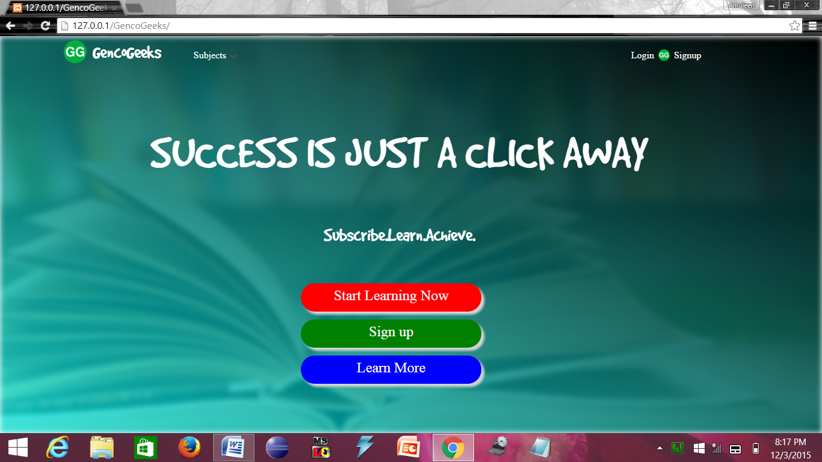

When the user types in the address of the website in the address bar, he/she is directed to this page. This page offers different functionalities like viewing the different subjects offered by the website, the option to login into the account or signup i.e. create a new account on the website.

When the user clicks on the ‘start learning’ option, he/she is directed to the login page where they can login to their account. When the user clicks on the ‘signup’ page, a popup appears asking the user for details to create their account on the website.

When the user clicks on the ‘learn more’ page, he/she is directed to the about us page where the user can know more about the website and also add their review.

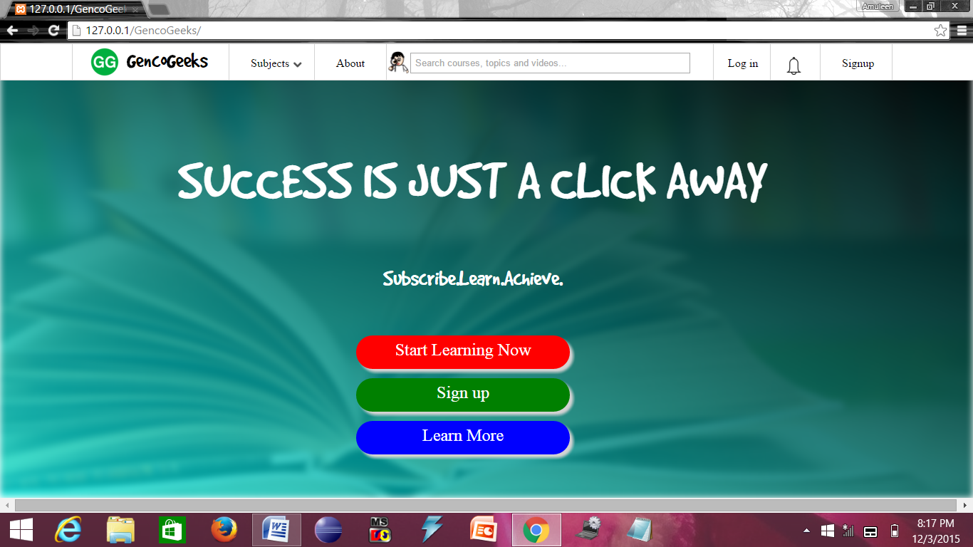

When the user hovers over the upper side of the page, more options appear as shown in the above screenshot.

**4.3.2. Payment page**

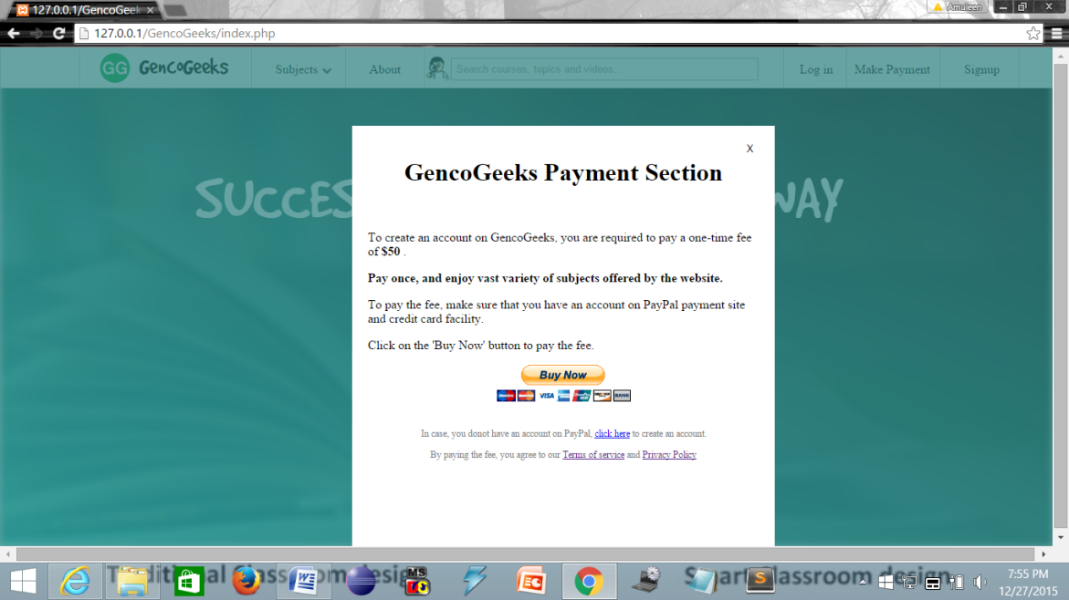

When the user wants to create a new account o the website, he/she is directed to this payment page where they have to enter their unique transaction id which they get once their payment to the site is successful. The transaction id entered by the user is then checked for validity and if valid, the user is directed to another page where they have to enter their personal information and then the account is created.

**4.3.3. Login page**

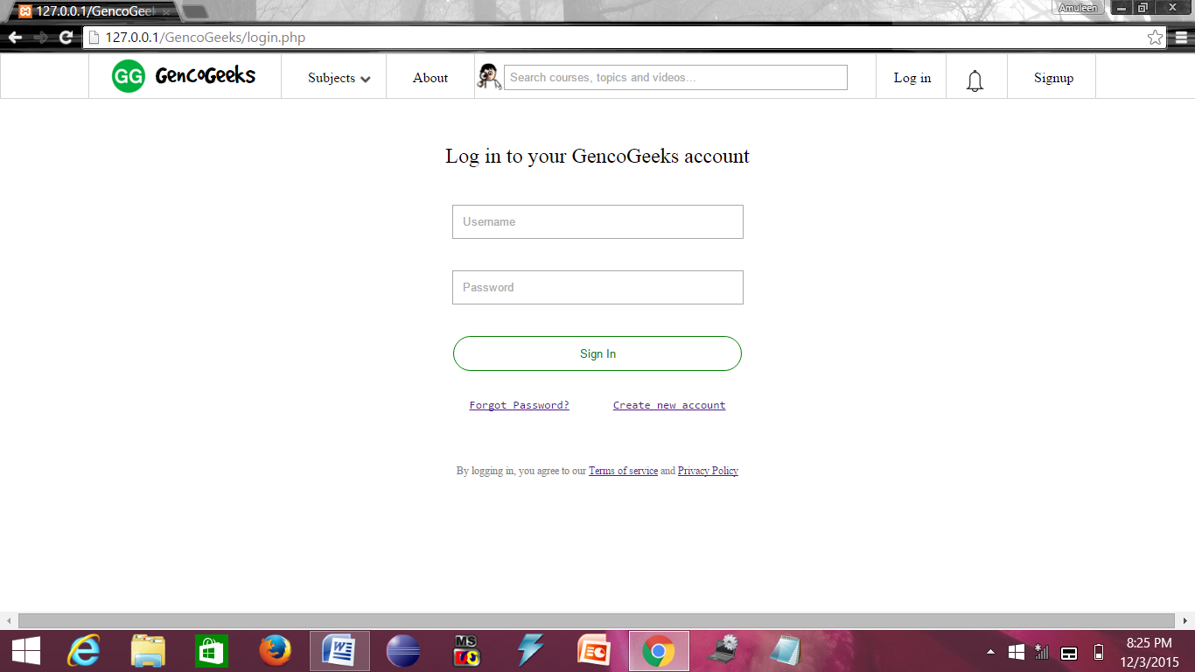

If the user is already registered with the website i.e. the user already has an account, then they just have to click on the ‘Log in’ option on the home page and they are directed to the login page as shown above. Here, the user is required to enter the username and password for their account which is then checked before directing the user to their respective portals.

Also, the user has the provision of recovering a forgotten password by clicking on the link provided on this page, following which he/she will receive the password via an email.

The user also has the provision to create a new account from this page by following the link provided below the login button. In case if the user wish to read the ‘Terms Of Service’ or ‘Privacy Policy’ of the website, they can do so by following the respective links provided on this page.

**4.3.4. Sample admin portal**

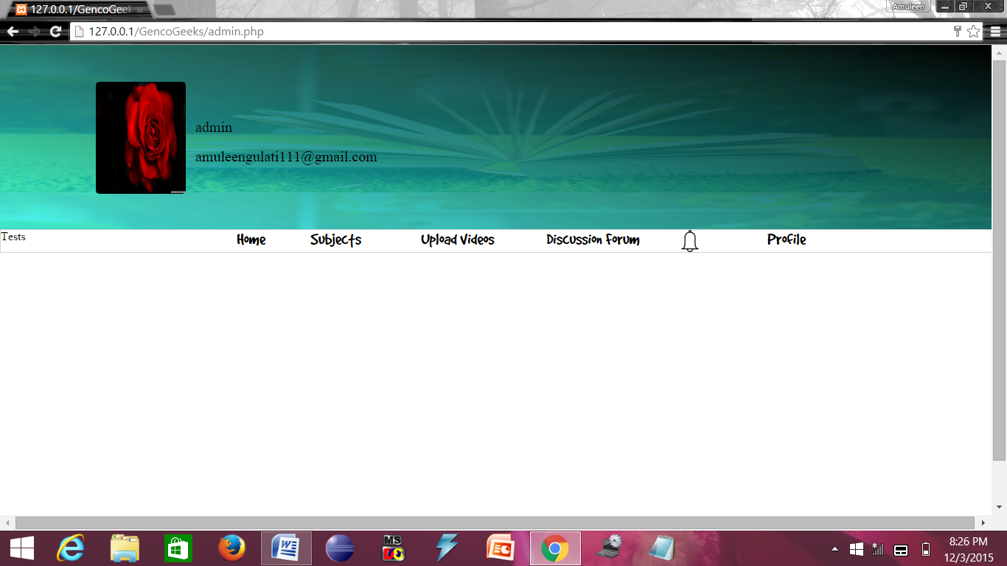

Each user of the website is provided with a unique username and password, and so is the admin. So, when the administrator of the website enters their login username and password on the login page, they are directed to this page as shown above.

The top section displays the following:

* Username, as specified by the admin.
* Email id of the admin.
* Profile picture, as chosen by the admin.

Then there are several options to enable different functionalities for the admin as follows:

* Subjects: To enable the admin to add new subjects or delete existing subjects offered.
* Upload videos: To enable the admin to upload new video lectures for the users.
* Discussion forum: To enable the admin to participate in the discussion forum and to create categories as well as regulate the discussion forum.
* Notifications: To enable the admin to generate notifications to the users of the website.
* Profile: To enable the admin to edit their own profile and to logout after finishing their work.

**4.3.5. Sample user portal**

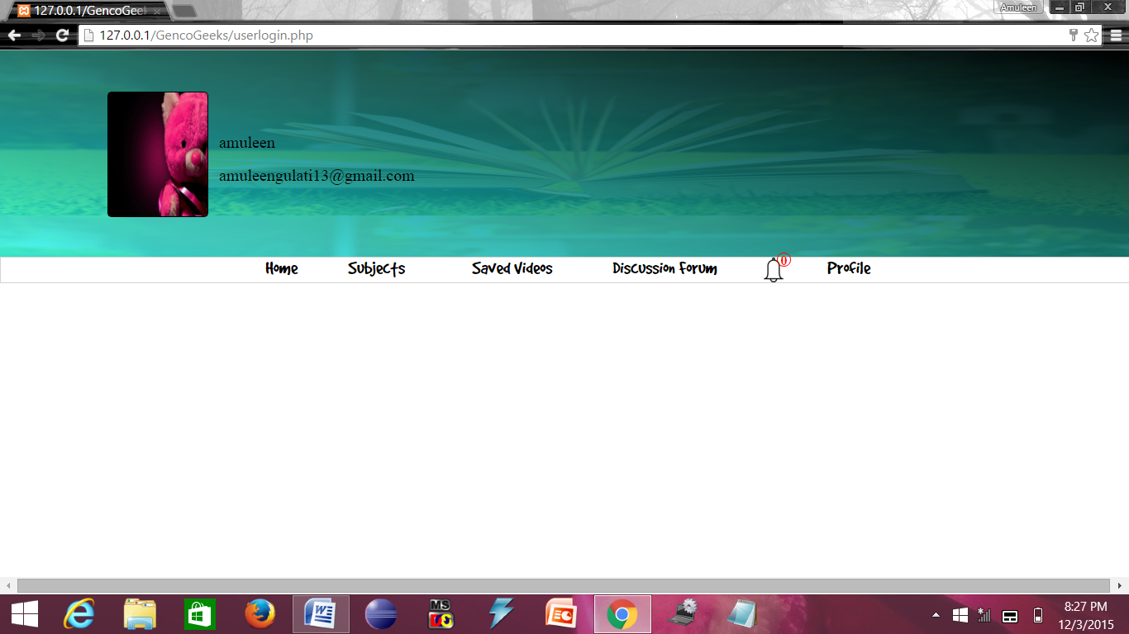

Each user of the website is provided with a unique username and password. So, when the user enters their login username and password on the login page, they are directed to his/her home page as shown above.

The top section displays the following:

* Username, as specified by the respective user.
* Email id of the user.
* Profile picture, as chosen by the respective user.

Then there are several options to enable different functionalities for the user as follows:

* Subjects: To enable the user to choose any subject from various subjects offered by the website.
* Saved videos: To enable the user to view all the videos which they have saved.
* Discussion forum: To enable the user to participate in the discussion forum.
* Notifications: To enable the user to get and read notifications generated by the admin of the website.
* Profile: To enable the user to edit their own profile and to logout after finishing their work.

**4.3.6. Some more user functionalities**



When the user selects a subject to study, then he/she is directed to the page of the respective subject. As an example, if the user selects ‘cloud computing’, then he/she will be directed to the page as shown above.

This page consists of some overview about the subject as well as three options:

* Videos: When the user clicks on this link, all the videos regarding the chosen subject are displayed along with their difficulty levels and descriptions.
* Tests: When the user clicks on this link, the user is directed to a page where a random test appears along with a timer, to enable the user to check their level of acquired knowledge on the subject.
* Saved videos: When the user clicks on this link, all the videos which have been saved by the user regarding the chosen subject are displayed to the user.

4.4. TESTING

Software Testing is the process used to help identify the correctness, completeness, security, and quality of developed computer software. Testing is not just a process of executing a program or application with the intent of finding errors. Quality is not an absolute; it is some value is used. With that in mind, testing can never completely establish the correctness of arbitrary computer software; testing furnishes a criticism or comparison that compares the state and behavior of the product against a specification.

The main motive of the project testing is to identify whether project is able to meet user requirements or not. There are basically three types of testing:

1. **Unit testing**, which finds faults by isolating an individual component using test stubs and drivers and by exercising the components using a test case.
2. **Integration testing**, which finds faults by integrating several components together.
3. **System testing**, which focuses on the complete system, its functional and non-functional requirements and its target environment.
4. **BLACK BOX TESTING**

Black box testing treats the system as a **“black-box”**, so it doesn’t explicitly use Knowledge of the internal structure or code. Or in other words the Test engineer need not know the internal working of the “Black box” or application. **Main focus in black box testing is on functionality of the system as a whole.**

We have used the **Error Guessing method for Black Box testing of our project.** Error guessing method is purely based on previous experience and judgment of tester. Error Guessing is the art of guessing where errors can be hidden. For this technique there are no specific tools are used. We detected the following errors using Black Box testing;

|  |  |  |  |
| --- | --- | --- | --- |
| S.NO. | ERROR | CAUSE | SOLUTION |
| 1. | Numbers could also be added in the name fields. | Validations missing. | Added Validations. |
| 2. | The user is not able to recover password if he forgets his/her password. | No mechanism was added to the project for this purpose. | Added this feature using the mail server to send an email containing the password of the user to their provided email. |

1. **WHITE BOX TESTING:**

White box testing (WBT) is also called **Structural or Glass box testing**. White box testing involves looking at the structure of the code. When you know the internal structure of a product, tests can be conducted to ensure that the internal operations are performed according to the specification. And all internal components have been adequately exercised. **White Box Testing is coverage of the specification in the code. White box testing is a complex task and requires much time and skill. So we relied on the unit, integration and system testing techniques rather than going for the white box testing.**

1. **UNIT TESTING:**

Unit testing is a software development process in which the smallest testable parts of an application, called units, are individually and independently scrutinized for proper operation.

**(i) File name: index.php**

|  |  |  |  |
| --- | --- | --- | --- |
| S.NO. | ERROR | CAUSE | SOLUTION |
| 1. | Parse error: syntax error, unexpected $end in C:\wamp\www\project\crime_management_system.html on line 227 | <html> tag not closed properly. | Added </html> tag to the end of file. |
| 2. | The jQuery functions were not working properly in internet explorer but worked fine in Google chrome browser. | JavaScript was not enabled. | Enabled JavaScript in the browser.  Tools-> internet options -> Security -> scripting options -> allow active scripting -> apply -> ok. |
| 3. | Scrollbar was not scrolling down in the browser window. | position: fixed was used for all the <div> tags in index.php file. | Changed the position property of the <div> tags from position: fixed to position: relative. |

**(ii)** **File name: login.php**

|  |  |  |  |
| --- | --- | --- | --- |
| S.NO. | ERROR | CAUSE | SOLUTION |
| 1. | Empty form was also being submitted. | No validation was applied to prevent the user from submitting an empty form. | Added the ‘required’ attribute in the form fields whose value cannot be empty. The user must fill all the form fields with the ‘required’ attribute before submitting the form. |
| 2. | The form was being submitted even if the password and re-type password fields had different values entered. | No validation was applied to check if the values of both the fields were equal or not. | Suitable code was added to the file login.php which first compared the values of both fields to check if they were equal before submitting. |

**(iii) File name: connect.php**

|  |  |  |  |
| --- | --- | --- | --- |
| S.NO. | ERROR | CAUSE | SOLUTION |
| 1. | Database Selection Failed: unknown database error on phpmyadmin | Database was not created in phpmyadmin. | Created the database in phpmyadmin with the name gencogeeks. |
| 2. | #1045- Access denied for user ‘root’ @‘localhost’ (using password: YES) | The root user does not require a password. But the password variable in connect.php was set to a non-empty value. | Set the $dbPass variable (containing the password for database connection) in the connect.php file to an empty value. |
| 3. | Notice: undefined index: dp in c:\ wamp\www\project\db.php on line 24 | The ‘dp’ attribute of the user_details table was not set. | Added an attribute ‘dp’ in the user_details table of the gencogeeks database. |
| 4. | Notice: A session had already been started – ignoring session_start() in C:\wamp\www\project\db.php o line 4. | The session_start() function was included twice. | Removed one of the session_start() functions. |
| 5. | Parse error: syntax error, unexpected ‘text’ (T_STRING), expecting ‘,’ or ‘;’ | php syntax error. | Corrected the syntax. |

1. **INTEGRATION TESTING:**

Integration testing (sometimes called integration and testing) combines the individual software modules and then these combined modules are tested as a group.

1. **Visitor Module**

|  |  |  |  |
| --- | --- | --- | --- |
| S.NO. | ERROR | CAUSE | SOLUTION |
| 1. | No link to get back to home page from the ABOUT US tab. | No link specified in the ABOUT US tab to link to the home page. | Added a new tab on the ABOUT US page to direct the user back to the home page. |
| 2. | Visitor was not able to see the description of the offered subjects after clicking on the button. | No internet connection. The specified link to which the button is directed requires an active internet connection as it refers a page on the internet. | Connect to a working internet connection. |

1. **Registered User Module**

|  |  |  |  |
| --- | --- | --- | --- |
| S.NO. | ERROR | CAUSE | SOLUTION |
| 1. | The user was not able to come out of his/her id. | The ‘href’ attribute was missing in the Log out tab | Added a ‘href’ attribute to the Log out tab which directed the user to the home page and unset the values of all session variables. |

1. **Administrator Module**

|  |  |  |  |
| --- | --- | --- | --- |
| S.NO. | ERROR | CAUSE | SOLUTION |
| 1. | Error: Table crms.category does not exist. | The table ‘category’ was not created in the gencogeeks database. | Created a new table named category in the gencogeeks database. |

1. **SYSTEM TESTING**

System tests are designed to validate a fully developed system with a view to assuring that it meets requirements. There are three kinds of system testing.

1. Alpha testing
2. Beta testing
3. Acceptance testing
   1. **Alpha Testing**

Alpha testing refers to the system testing that it’s carried out by the customer within the organization along with the developer. The alpha tests are conducted in a controlled manner.

|  |  |  |  |
| --- | --- | --- | --- |
| S.NO. | ERROR | CAUSE | SOLUTION |
| 1. | Numbers could also be added in the name fields. | Validations missing. | Added Validations. |
| 2. | No procedure used to delete the contents of the database after certain number of entries to prevent overloading. | ---------------- | Added a constraint to the database which will automatically delete all the entries from the login_details table after 1000 entries. |

* 1. **. Beta Testing**

Beta testing is the system testing performed by a select group customer’s .The developer is not present at the site and the user will inform the problems that are encountered. As a result of problems reported during the Beta test, the software developer makes the modifications and then prepares for release of the software to the customer.

|  |  |  |  |
| --- | --- | --- | --- |
| S.NO. | ERROR | CAUSE | SOLUTION |
| 1. | The user is not able to recover password if he forgets his/her password. | No mechanism was added to the project for this purpose. | Added this feature using the mail server to send an email containing the password of the user to their provided email. |
| 2. | Some hyperlinks on some pages not working. | Missing ‘href’ attributes for the respective links. | Added suitable ‘href’ attributes. |

CHAPTER-5 CONCLUSION AND FUTURE SCOPE

5.1. CONCLUSION

**Aim:** The aim of this project is to develop and deploy an all-in-one learning solution to the students of the college so that they can use their free time effectively by learning new skills just at the click of a button.

**Conclusion:** This project has been successfully created to achieve all of its desired goals. This project has been tested on the following parameters:

|  |  |  |
| --- | --- | --- |
| **S.NO.** | **PARAMETER** | **OUTCOME** |
| 1. | Easy-to-use user-friendly interface | Positive |
| 2. | No expensive hardware or software required for project deployment. | Positive |
| 3. | Effective time utilization of students. | Positive |
| 4. | All in one learning solution. | Positive |
| 5. | Guaranteed quality training. | Positive |

5.2. FUTURE SCOPE

Based upon the reactions of the users and the availability of the trainers, this project can further be extended to include the ‘video conferencing’ feature wherein there will be face-to-face discussion between the tutors and the students.

More features may be added after the implementation of the project based on its popularity among the students. This project can be further developed into an e-classroom in future.

REFERENCES

The following sites were referred:

<http://www.stackoverflow.com>

<http://www.khanacademy.org>

[www.000webhost.com](http://www.000webhost.com)

[en.wikipedia.org](fILE)

[www.siteforinfotech.com](http://www.siteforinfotech.com)

[www.sanfoundry.com](http://www.sanfoundry.com)

[csetips.catchupdates.com](fILE)

<https://www.w3schools.com>

APPENDIX

ANALYSIS OF EXISTING SYSTEM

In 2012, a survey was conducted by AICTE-CII on the industry-linked institutes. One of the objectives of the survey was to analyze how far the existing curriculum of the engineering colleges in India meet the existing industry trends.

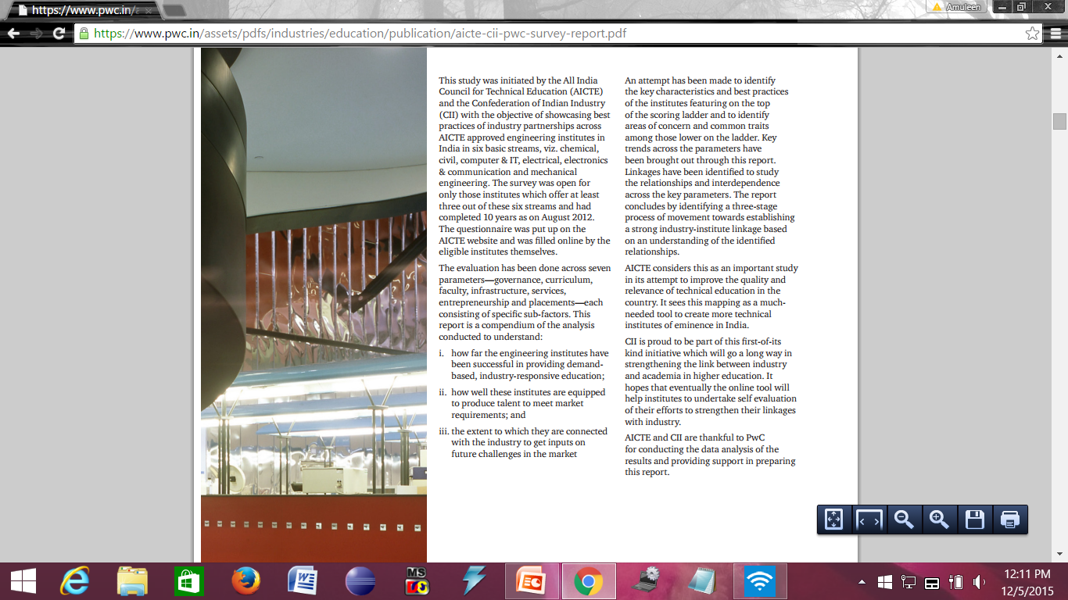

The figures clearly show that although the number of engineering students has been increasing over the past years but the number of students getting hired is constantly decreasing. A major factor for this outcome is that the quality of education system is not up to date with the demands of the industry.

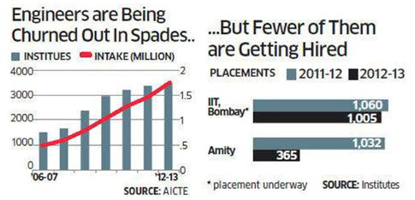

Figure : AICTE Survey result

After careful analysis of the existing system, it was inferred that the existing curriculum of the institution does not agree with the latest industry trends and thus there is a major need for a system to impart demand-based knowledge to the students aspiring to be in the IT industry.

